LEAP @ THS

**L**earning **E**nrichment and **A**cceleration **P**athways

# Expression of Interest 2026 - LEAP

*Please ensure the application is fully completed and returned to the Toronto High School Front Office by* ***Friday 4th April 2025*** *to register for the LEAP Higher Ability Selection Test (HAST) being administered on* ***Wednesday******7th May 2025.***

Applications may be dropped at the Front Office or mailed to:

Melynda Smith-Kain HPGE Co-ordinator Toronto High School Field Avenue Toronto, NSW, 2283

Confirmation of the receipt of your application and further details regarding attending for the administration of the HAST on 7th May 2025 will be forwarded to the mailing address and/ or email provided below.

**Applicant Family Details**

Student Name: Primary School:

Parent(s)/Caregivers(s): Address:

Mailing Address:

Email:

Phone Number: ______________________________

**Note –** Please attach copies of your child’s **most recent school report**

# and Yr5 NAPLAN results

*Please see over and complete.*

**Student Information: Parent Completion**

Please describe your student’s strengths and educational achievements.

Outline participation in extra-curricular activities / interests.

Are there any special needs or considerations required for the selection process? *eg Vision impairment requiring enlarged print of test materials.*

*Yes / No (If yes please provide details below)*

Any additional information which could be used to support your student’s learning at Toronto High School?

_________________________________________________________________________________________________________________________________________________________________________________________________________________________________

**­­­**

**Student Completion**

**How do you like to learn? Why?**

_____________________________________________________________________________________________________________________________________________________________________________________________________________________________________________________________________________________________________________________________________________________________________________________________________________________________________________________________________________________________________________________________________________

**Choose one image from below and explain how this relates to you.**

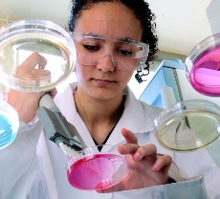  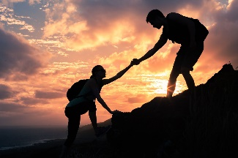  

_____________________________________________________________________________________________________________________________________________________________________________________________________________________________________________________________________________________________________________________________________________________________________________________________________________________________________________________________________________________________________________________________________________

**Why would you like to be in the LEAP program at Toronto High School?**

___________________________________________________________________________________________________________________________________________________________________________________________________________________________________________________________________________________________________________________________________________________________________________________________________________________________________________________________________________________________________________________________________________________________________________________________________________________________________________________________________________________________________